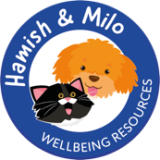
Re. Hamish & Milo Wellbeing Programme

Dear Parent/Guardian of (insert child’s name)
Hamish & Milo is a wellbeing programme led by a professional in school as part of the PSHE curriculum, covering various topics relating to social, emotional and mental health (please see the Hamish & Milo information sheet attached for more detailed information) and or visit hamishandmilo.org.
We feel that that your child would benefit from working in a small group using the Hamish & Milo programme to help support their wellbeing. The group will be led by (staff member’s name) during the normal school day, with 5-6 pupils attending one 45–60-minute session every week for ten weeks.
If you wish to discuss the support your child will receive, please do not hesitate to get in touch with me or make an appointment for us to have a further conversation.
Please sign the permission slip below if you are happy for your child to participate.

Kind regards,
(staff member’s name)
__________________________________________________________________________________
I have read the letter regarding Hamish & Milo Wellbeing Programme sessions and I hereby give my permission for (insert child’s name) to attend.

Signed: (Parent/Legal Guardian)
Date: (Today’s date)

